Department of Medical Imaging
Grand Rounds

Sponsored by The University of Arizona College of Medicine – Tucson

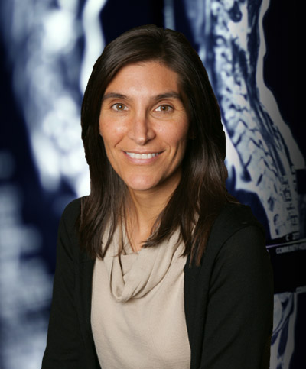
AI in Clinical Practice

Wednesday, March 17, 2021
@ 12:00 pm

ZOOM Meeting

Nina Kottler, MD, MS

Radiologist, VP Clinical Operations Radiology Partners

El Segundo, CA

Outcome Objectives:
1.) Discuss the current maturity of AI in Radiology and hypothesize what should happen in the next few years
2.) Review several reasons why AI is not prevalent in the clinical use
3.) Illustrate AI applications in clinical use

Accreditation Statement:
The University of Arizona College of Medicine - Tucson is accredited by the Accreditation Council for Continuing Medical Education to provide continuing medical education for physicians.

The University of Arizona College of Medicine - Tucson designates this live activity for a maximum of 1.0 AMA PRA Category 1 Credit(s)™. Physicians should claim only the credit commensurate with the extent of their participation in the activity.

Disclosure Statement(s):
All Faculty, CME Planning Committee Members, and the CME Office Reviewers have disclosed that they have no financial relationships with commercial interests that would constitute a conflict of interest concerning this CME activity.

ZOOM Meeting - https://arizona.zoom.us/j/89875451930
CME code - 367600

